Further Studies into Solar Transiting Aspects and the Time of Death

Brian T. Johnston, Bsc.

A second study of the timing of deaths due to due transiting aspects of the sun of the 24th harmonic was undertaken to see if the results of the previous study were due to synchronicity, or were verifiable results. The premise is that the number of deaths that occur on a day where the natal sun is aspected by the transiting sun by an aspect of the 24th harmonic, or every fifteen degrees, than at any other time. Astrology since the time of Jung has been under the stricture that the results are somehow due to a mantic, magical procedure. In other words fortunetelling. This has of course been an accusation of astrology since ancient times.

During the 12th and 13th centuries astrology was being re-introduced into Western and Northern Europe and the main criticisms were as they had always been that the stars could not possibly affect life on earth, let alone an individual person. The results of the many different astronomical studies that now link the positions of the planets and electromagnetic weather of the solar system are too many to reference. The studies started with the astronomers of the 19th century who were convinced that the planets were affecting the rate of sunspots. Professor Carrington was one notable in this field at the time. (A Practical Treatise of Astral Medicine and Therapeutics - 1912, Dr D.M. Duz, Bogata, Colombia, pg 15.) The University of Colorado studies ( http://brianjohnston200.wix.com/skepticsand-science#!planetary-harmonics-and-the-aurora/curf) prove that not only do the planets positions affect the rate of sunspots. but they can be correlated with climate changes on the earth over vast periods of time. Now we can see that the forces at work in the basics of astrology are physical and not a phantasmagoria.

To answer the age old question; the planets do affect life on earth and the repetition of the birth and death study is enough to say that it is affecting individuals. Many studies over the years have shown good results and if they were in any other field of study they would have been taken seriously. I have read many good and valid studies in the International Astrologer and other reputable magazines and journals that would be valid if they were not considered to be pseudoscience.

In the first study the same procedure was followed as in the original test. Thirty one famous people were selected at random from the website: http://www.famousdead.com/category/historical/ http://www.famousdead.com/category/historical/page/2/ . www.famousdead.com/archive , www.famousdead.com/archive/?=1 www.famousdead.com/archive/?=2 , www.famousdead.com/archive/?=3 and www.famousdead.com/archive/?=4 . www.famousdead.com/comedian , www.famousdead.com/criminals , and www.famousdead.comactresses ,

When we combine all the data from the original study of 109 individuals and the subsequent individuals as stated above we have a combined total of 250. While second batch of 141 individuals did not have as high a rate of adherence to death as the first batch there were 37% of the people who died +/-2 degrees of the aspect. The expected rate was 33%. At the one degree orb the rate was 23%. The expected rate was 20%. At the 2 degree orb there are 10% more deaths than expected that adhere to the criteria, while the 1 degree orb this increases to 11.3% greater than expected.

In our original study, which has been modified slightly to include 109 deaths from the same sources (see: http://brianjohnston200.wix.com/skepticsand-science#!data-births-deaths/cle4 ,) we find that there were 47 deaths within two degrees of a solar aspect of the 24th. harmonic. The expected was 21.8. There were 43% of people who died during these periods when compared to the expected 33% which is quite startling. By combining all three studies of 250 death timings there were 92 people who died within 2 degrees of an aspect occurring, or 37% of people died during these periods. The expected number of people to die during these periods is 83, or 33%. This is the same as throwing a 5 sided die 171 times and getting 92 fives, when you should only get 83 fives. In neither of the databases was it found that the number people who died were less than the odds against chance. You would win at Vegas every time. If you bet $100 once every minute on 5 you would make $216 an hour, or $1,728 in an eight hour day. Not bad wages. In other words impossible and not related to any synchronicity.

The batch of the criminals had the highest incidence of dying on the 24th harmonic with 17 out of 30 within a two degree orb. This is almost 57% of these individuals dying during these periods. The expected number is 10, or 33%. It may be that these individuals had less access to medical attention than the individuals in the other batches.The actresses had the lowest incidence with only 9 out of 32 dying during the critical periods. They most likely, in contrast had the best medical care out of the study. This may help to reduce the interference from medical intervention in the study.

For the first 205 individuals a t-test was performed against a database of random numbers.

Here are the results the unpaired t-test against random numbers:
P value and statistical significance:
The two-tailed P value equals 0.0018
By conventional criteria, this difference is considered to be very statistically significant.

Confidence interval:
The mean of Group One minus Group Two equals -16.32
95% confidence interval of this difference: From -26.55 to -6.09

Intermediate values used in calculations:
t = 3.1391
df = 340
standard error of difference = 5.199

Another study was undertaken to see if the kinds of causes of deaths affect the results. The data was again taken from www.famousdeaths.com/?=causes/heartattack/1 , 2 and 3. The first thirty individuals found on this database were analysed and it was found that 13 people died within an orb of 2 degrees of a 24th harmonic aspect. This is 43% of the people, while only 33% was expected.

A second study was done on cancer patients and it was found that out of 30 individuals 13 died during the critical periods. This exactly the same rate of adherence to the premise as the heart attack victims. The data was secured from www.famousdeaths.com/?=causes/cancer/1 2 and 3. When we combine both studies there are 26 out of sixty people who died during 24th harmonic aspects of the sun +/- 2 degrees.

If we now combine all the data from every study we have 118 people died during the critical periods out of 310 individuals, or 38%. The expected number is 103 people dying during these periods, or 33%.

Some of the main objections against astrology have been that what happened when you were born in the cosmos could not possibly affect you during your life and it would be impossible for you to be influenced by aspects to the natal horoscopic positions of planets, signs and houses. Another objection has been that when you were born would not be as important as when your conceived. One of the main objections has been that many have said that the divisions of the zodiac are arbitrary and such things as signs and degrees are imaginary.

Harmonics was rejected by most astronomers after Johannes Kepler as they felt it was astrological. Now we know that the orbits of the planets are locked into harmonic sequences like music, just Kepler stated in “The Harmony of the World.” In Book Five he relates the orbits of the planets to music. This is now known to be absolutely true. We can see from these studies that the lives of people can be effectively analysed through harmonic relationship between the natal sun and the transiting sun. When a car is made it is not a car until it is started and if it works then you can call it a car. Many cars don’t work properly when they are at the end of the assembly line and so, cannot be fully considered to be functional cars. Their inception is on a computer and they are not cars until they are truly cars. People are not people until they are born and just like the computer drawings when they are conceived there can be many revisions to the final product before it is in the que to be sold.

Why did Kepler need to come up with true of the planetary orbits?

The answer is: so that he could predict the future better. We must that remember he was the astrologer for the Emperor.

From the study we now can see that indeed we are affected by our natal charts and that the transiting aspects can affect us and even cause our deaths.

Are the planets causes then?

Yes, they must be as they vibrate and produce “music” that disrupts our own harmonic balance and so can cause major disruptions to our state of being and thereby propagate our death scenarios. Albert Einstein once said that space itself was the eather and carried the vibrations. This idea never caught on, but it appears to be the case. The solar system has dark matter in it as well, not much, just about enough for a small asteroid and it appears to be associated with the planets. What it is doing is unknown, but just goes to prove we still know very little about the true nature of reality.

In conclusion we can now confidently state that the transiting solar aspects against the natal sun of the 24th harmonic produce states of stress that result in a greater number of deaths than would be expected if the results were due to random chance. The results show that the astrological influences of the planets do affect people in profound ways and must be incorporated into the mainstream of science and medicine. No doubt with this preknowledge many lives could be saved if the proper preventions were in place to guard against these critical times. In the illustrations below the data is analyzed by various harmonics and the results are extremely informative

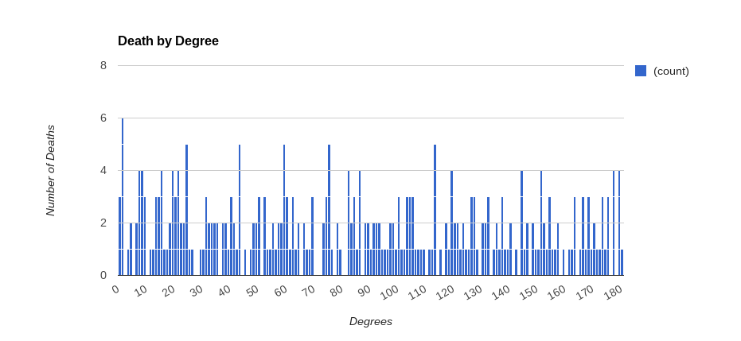

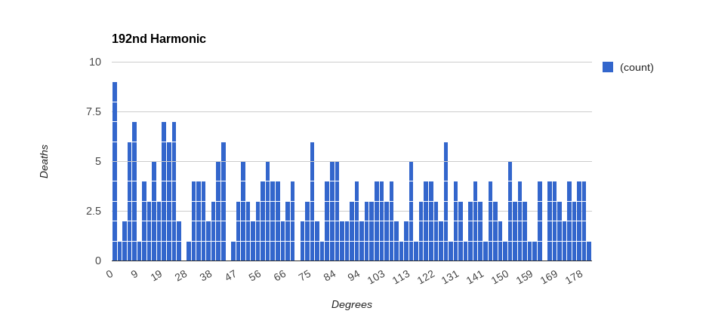
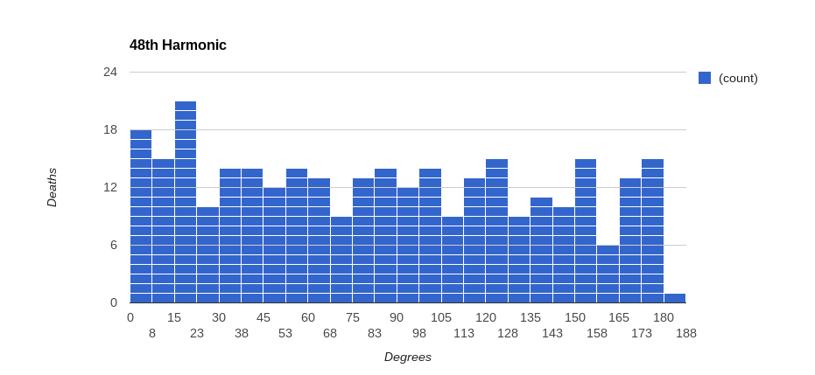
The harmonic charts show the definite peaks around the aspects of the 24th harmonic. These charts also seem to indicate a beat pattern at the48th harmonic. This becomes more apparent when we analyse the degrees from the time of the aspect and the actual time of death. The next chart illustrates this. It shows the death times before and after the actual time of the aspects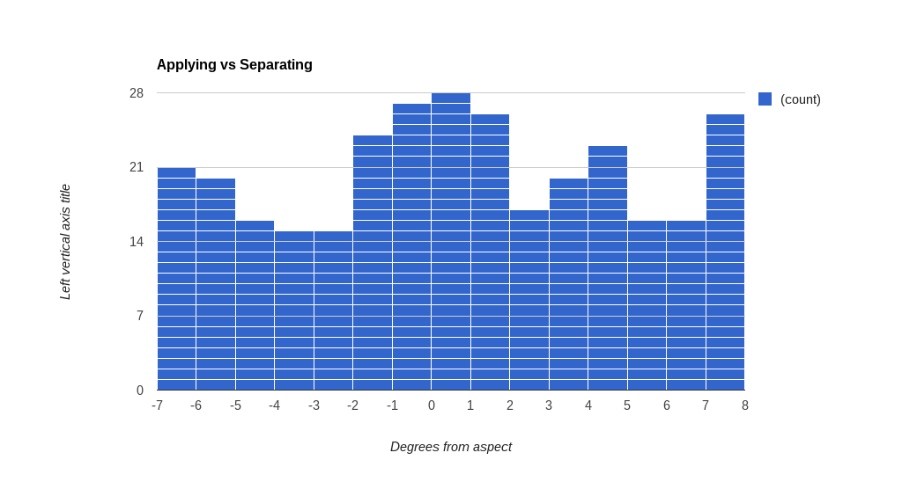
There is a clear peak at the center point around +/-two degrees. but there the chart appears to be bimodal with peaks at +/-7 degrees. The next chart shows the timing analysed by the 48th harmonic.
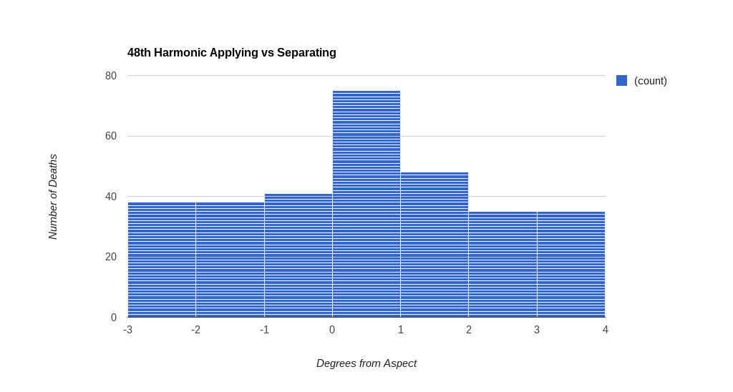With this chart we can clearly see the peak at zero degrees and at +/-1 degree from aspect. In other words this chart shows normal distribution for every 7.5 degree angle between the transiting sun and the natal sun for the timing of the individuals deaths.

For the number of degrees from aspect for the 24th harmonic the mode is one. This suggest strongly that the closer you are to the day of the aspect the more powerful it is. For the degrees from aspect applying versus separating the mode is always zero indicating that for both the 24th and 48th harmonics the actual day of the aspect is where the most powerful effect is seen.

From all of the studies we have examined in this article we can see that there is a definite statistical correlation between the day you are born and the day you die that is dependant upon the solar transiting aspects to the natal position of the sun.

