Planetary Aspects as the Cause and Timing of Terrestrial Earthquakes

By

Brian T. Johnston. Bsc.

Abstract

This is a study of the relationship between the planetary aspects, which are the geometric angles occurring between the planets as they orbit the sun, and the rate of earthquakes that occur over time on the earth. Planetary aspects are the precise angles that are formed between the planets as they orbit the sun. From the vantage point of the earth they form these angles due to the relative position between the planets and the position of the planet in it’s orbit. These angles, or aspects have been claimed by astrologers since time immemorial to be responsible for many natural disasters, including earthquakes. Astrologers have also claimed that events tend to occur more more frequently, but not exclusively, before an aspect occurs. There has never been a comprehensive study undertaken to validate, or disprove this claim. This paper will seek to carry this task out through observations made over time of the rate and timing of earthquakes and the correlation with the timing of the planetary aspects. It will be shown that there is a definite and sound statistical correlation between the planetary aspects and the timing of the occurrence of large earthquakes over time and that there is an overwhelming tendency for the earthquakes to occur just before a planetary aspect.

----------------------------------------------------------------------------------------------------------------------------

This is a study of the relationship between the planetary aspects and the rate of earthquakes that occur over time on the earth. Planetary aspects are the precise angles that are formed between the planets as they orbit the sun. From the vantage point of the earth they form these angles due to the relative position between the planets and the position of the planet in it’s orbit. These angles, or aspects have been claimed by astrologers since time immemorial to be responsible for many natural disasters, including earthquakes. Astrologers have also claimed that events tend to occur more more frequently, but not exclusively, before an aspect occurs. There has never been a comprehensive study undertaken to validate, or disprove this claim. This paper will seek to carry this task out through observations made over time of the rate and timing of earthquakes and the correlation with the timing of the planetary aspects. All the aspects used in this study are geocentric, in other words as observed from the vantage point of the earth.

Preliminary studies were made and published, mostly in The International Astrologer, the Journal of The International Society for Astrological Research, and by the University Center for Astrological Research (CURA) in Paris, France, by myself in the late 1990’s and the early 2000’s to determine which, if any factors used by astrologers to determine the nature of events were valid and able to be correlated with the rate and timing of earthquakes. No factors used by the astrologers, such as the signs of the zodiac the point where the zodiac intersects the eastern horizon, known as the ascendant, the midheaven, the point where the zodiac is intersected by the local meridian, or any of the houses, the twelve divisions of space and time around the earth, were found to be statistically significant. Other factors such as the eastpoint, asteroids, the nodes of the moon, planetary nodes, and arabic parts were all tested, but none of these factors were found to be significant in the rate, or the timing of earthquakes. All the aspects that astrologers used were tested. They are constructed by dividing the circle into various sub units by dividing the circle by various numbers such as seven, nine, ten and twenty four. All aspects were tested and the only aspects that seemed to have any significance were the the aspects created by divided the circle of 360 degrees by 24. In fact this was the only factor tested of all the elements used by astrologers to have any significance at all. The only aspects that were used for the study of the 24th harmonic were the ones traditionally used by astrologers. Zero degrees, 30 degrees, 45 degrees, 60 degrees, 90 degrees, 120 degrees, 135 degrees, 150 degrees and 180 degrees. Fifteen degrees, 75 degrees, 105 degrees and 165 degrees are not generally used by astrologers and so were not included in the tests. (For the complete summary of the original studies undertaken during the 1990’s and early 2000’s please see: http://brianjohnston200.wix.com/skepticsand-science#!astrological-research/c1wy6http://brianjohnston200.wix.com/skepticsand-science#!astrological-research/c1wy6 and http://brianjohnston200.wix.com/skepticsand-science#!astrological-research-pg-2/c1y1h )

The premise is that if no astrological factors have any effect that is detectable on any physical system on the earth, then astrology cannot be real and is fact a giant hoax, as many sceptics declare. The data base for the earthquakes was derived via the search feature on the USGS website. (1.)This is easily searchable by anyone wishing to verify the timing and positions of the earthquakes. All earthquakes greater 1.5 on the Richter scale were used as the criteria for quake selection. This finally resulted in database of 1453 earthquakes for which horoscopes were erected to the exact second of time and to the minute of longitude and latitude for the as to the indicated position of the events. The computer program Solar Fire was used for these calculations which is accurate for the positions of the planets to the arc second and for the moon to less than 10 arc seconds. The aspects were calculated the the nearest arc minute. The first and main test of the hypothesis was to see whether, or not the earthquakes would occur more frequently just before, or just after an aspect occurred.

To summarize the previously published studies what was found that with the final database of 1453 earthquakes 61.5% of the earthquakes occurred when the planetary aspect that was closest to the exact angle of the aspect was applying and 38.5 of the quakes occurred during separating aspects. The results of these test were well in excess of 5 sigma and more than enough to prove a true observation. It was also found with a study involving several thousand earthquakes that the frequency of all earthquakes greater than 1.5 on the Richter scale increased in the three days leading up to the time of the aspect and peaked in the day before the actual astronomical event took place. (See graph 1.) These observations demonstrated a definite increase in the rate of earthquakes in the three days leading up to a quakes, which peaked on the day before the actual aspect occurred, and then dropped back to baseline after the aspect occurred within two days. (2.) About five days for the cycle to transpire. This is relevant due to the fact that the aspects of the 24th harmonic are 15 degrees each and when you divide 360 by 45, which is 3 times 15, then you get five. This will be shown to be relevant later in this paper.

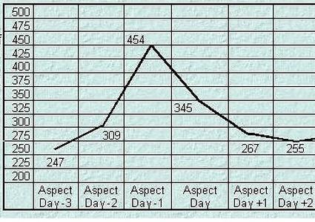
Graph 1.: A Number of aspects between the outer planets were studied and the number of quakes per day for the 3 days before and 2 days after the timing of the aspect were tallied and the resulted curve is noted above.

From the previous studies it was definitely proven that there is statistical link between the orbital positions of the planets and natural physical phenomena, in the form of earthquakes, on the earth just as astrologers have long claimed. In the intervening years there has been little attention paid to these discoveries and I decided to make a replication of the these studies through a detailed series of observations which were made of the rare geometrical configuration, known as a Grand Cross by astrologers, between the planets Mars, Jupiter, Uranus and Pluto. The main event was to occur on April 19th when Jupiter made an exact square of 90 degrees to Uranus and was in opposition to Pluto at 180 degrees. Observations started on February 18th., 2014 and were continued until May 5th., 2014. Only earthquakes greater than 6.0 were observed as the astrologers were anticipating there to major physical events to happen during this period.

During the period of the observations there were 39 earthquakes greater than 6.0 on the Richter scale.. Over the previous year there were 156 earthquakes of this magnitude, this already indicates a possible anomaly as this is 18% more quakes than expected for this timespan. Of the 39 quakes 34 occurred just before an aspect occurred and only six happened just after an aspect occurred. As there is a fifty percent chance for an earthquake to occur before and aspect and the same afterwards then the odds against chance for this are 2 to the 28 odds against chance that the planetary aspects are not causing the earthquakes timings. 134,217,728 odds against chance. Well beyond the 5 sigma required by the Astrophysical Union for a true observation. (for all the charts and the commentary on these observations please see: http://thecanadianinstituteforappliedastronomy.yolasite.com/research.php )

Further observations for the number of earthquakes of this magnitude to occur between September, 2013 and May 5, 2014 were carried out and graphed. It was then divided into five day segments and the number of earthquakes to occur every five day period was tallied. It was found that the period encompassing April 19th was the highest peak on the graph with five earthquakes occurring during this period of magnitude greater than 6.0 on the Richter Scale. It was also discovered that by dividing the period into five day segments a sign wave of earthquake frequency appeared. In the Study period there was definite sine wave where during one five day period there would be a maxima of earthquakes and in the next period there was a minima of quakes. (See graph 2.) When the entire span from September to May was examined it was noted that this sine wave was evident during the entire study period. It would go periodically through a polarity change where there would be two five day periods with maxima in a row and then it would return to the sine wave periodicity. Other periods were tried, such as three days and seven days, but there was no real indication of any periodicity in these cycles. Only the five day period exhibited the sine wave phenomena. The changes in polarity were found to be associated with the orbit of the earth and Venus and was associated with the aspects between them. When the earth and Venus make an aspect this tends to repeat the maxima of earthquakes for ten days and then the rate of quakes returns to a minima.

A complete analysis of the earthquakes from January 8th to May 29th somewhat surprisingly illustrates that the highest peak of 6 quakes during the period between the 12th to the 17th of May, which was after the aspects of the grand cross occurred. During this period, however, the inner planets made aspects with Neptune, Uranus and Pluto. On the 12th the sun was at 75 degrees to Neptune. and there was a 6.5 near the SE Pacific Rise. On the 14th Venus was 90 degrees from Pluto and Mercury was 150 degrees to Pluto as well and there was a 6.5 in Panama and a 6.1 in Micronesia. On the 15th Mercury was 60 degrees to Uranus and Venus in conjunction to Uranus as well and there was a 6.6 in the Philippines and a 6.0 in Guadalupe. These aspects appear to have re-energised the activity of the grand cross during this period. After this period the number of large earthquakes return to zero for the next ten days. Taken together this appears to be indisputable proof that the aspects of the planets time the occurrence of large earthquakes and probably actually create the physical conditions needed for them to spawn. (See graph 2. also Table 1 at the end of this article.)

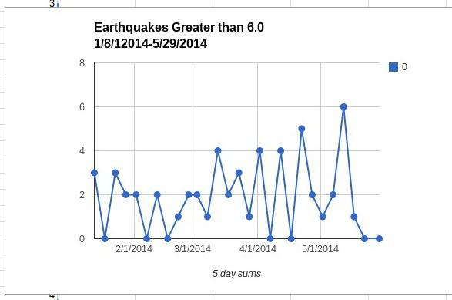
Graph 2.; For the period leading up to April 19th, 2014 there was a periodicity where for five days the number of large earthquakes was high, and the during the following five day period the number of quakes was low. The second highest peak of 5 occurred during the time frame of the Grand Cross between Pluto, Uranus, Jupiter and Mars, while the highest peak of 6 was during the period when the inner planets made aspects to Neptune, Uranus and Pluto from May 12th to the 17th.

Another notable feature of this time period was the 8.2 quake that occurred off the coast of Chile near Iquique on April 1st was the 13th. largest earthquake ever recorded. This was the day that the sun was making a conjunction to Uranus, one of planets involved with Grand Cross that was to occur on the 19th of April. The sun was only 17 arcminutes from the exact conjunction and applying. This was very large quake with an energy of about 15 megatons of TNT. Another possibly significant observation is that in December 2013 there were very few earthquakes and there were also very few aspects of the outer planets. The exception was the 120 degree, or trine aspect, between Jupiter and Saturn.

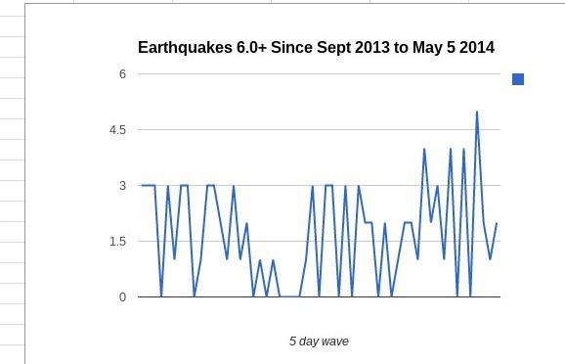
Graph 3.: The periodicity of the frequency of large earthquakes can be show to be a standard phenomena of the timing of earthquakes as seen in this graph of large earthquakes between September 2013 and May 2014 where the number of large earthquakes greater than 6. are grouped into five day periods. It can also be seen that the period around April 19th, when the 90 degree angle between Jupiter and Uranus took place is the highest point on the graph for the whole period. The lowest period on the graph represents December 2013 when there were few outer planetary aspects.

By also observing the spin rate of the earth which decreased around March 16th, the 29th of March, the 15th of April and the 24th of April. All of these periods were associated with an aspect between Venus and other planets. On April 24th. as the spin rate of the earth was reaching minima Venus was at 120 degrees to Saturn. On April 14th Venus was 45 degrees to the Sun. On April 1st Venus was at 135 degrees to Jupiter and at 45 degrees to Pluto. On the 16th of March Venus was at 150 degrees to Jupiter and then the next day was at 60 degrees to Uranus. While this still is as of yet anecdotal it is highly suggestive of the mechanism between the planetary aspects and the rate of earthquakes as it may be related to the spin rate changes of the earth. (See graph 4.) The period around April 19th shows an increase in the spin rate of the earth. On May 4th the spin rate of the earth was at it’s greatest and on this day the Sun was at 60 degrees to Jupiter. This was associated with 4 earthquakes greater than 6.0 during that period. There was a 6.6 in Fiji, followed by a 6.0 near the same place. Then there was a 6.0 in Japan and finally on the morning of the 5th, there was 6.0 in Thailand. This is a strong association with the aspect of the Sun and Jupiter and is a indicator that the 60 degree aspect between the Sun and Jupiter was responsible for the increase the earth’s spin rate. The two highest peaks on the graph, March 30th and April 28th are also new moons, showing that there is a tidal element involved here. The other smaller peaks are near the full moons of March and April. It takes an enormous amount of energy to change the spin rate of the earth. These periods however, are not significantly associated with any large earthquakes and so, it would appear that the tidal component is not associated with the change in the number of large earthquakes. (3.)

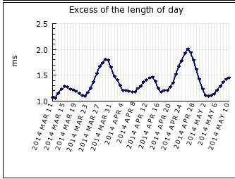

Graph 4.: On this chart the higher points represent a longer day. The lowest points on the graph represent the higher spin rates of the earth. The period around April 19th shows a high spin rate and then an abrupt decline in the spin rate of the earth. The next rise in the spin rate was about May 4th to the 6th when the sun was moving first at 120 degrees to Pluto, then 30 degrees to Uranus and finally at 60 degrees to Jupiter on May 6th.

In conclusion we can see that in fact the planetary aspects are associated in time and space with the timing of earthquakes. The evidence is also strongly suggestive that the planetary aspects affect the spin rate of the earth, which may be the physical mechanism broadly responsible for the changes in the number of earthquakes that are associated with these events. The observational results are well beyond the 5 sigma correlations needed to prove a true observation of an astrophysical phenomena.

The beat frequency patterns observed in the data for the rate of large earthquakes over time are most likely a result of the interacting frequencies of the planets involved. What remains a mystery is where these vibrations are coming from. The most likely progenitor of these waveforms is the orbital resonances of the participating planets. It appears, if this is the source of the phenomena, that these resonances are amplified at certain geometrical angles which correspond to the angles of the 24th. harmonic. The 5 day beat frequency of the rate of large earthquakes observed is very likely due to the heliocentric orbital period of Venus. The period of Venus is 225 days. when we divide 225 by 15 we get 15 days, almost the exact period of the orbit of the earth divided by 24. We can see from this that there would be a harmonic beat frequency of five days as prime harmonic of the orbital resonance of the Earth and Venus. The 24th harmonic of the earth is about 15 days and the 24th harmonic of the period of venus is 9.4 days, very close to the beat frequency observed If we use the beat period formula, F1-F2, then we have 5.6 days, very close to the beat frequency observed in the data. The resolution of the data is too coarse to reveal a beat frequency difference between the observed rate of 5 days and the predicted rate of 5.6 days. As a result it is logical to conclude that the sinusoidal curve observed in the rate of large earthquakes is a result of the the 24th harmonic interactions between the orbital resonances of the Earth and Venus. I have not been able to find anything in conventional astrophysics which would explain this clearly observed phenomena.

If we divide the orbital periods of the planets by the 24th harmonic we get for Mercury, 3.67 days. Venus 9.4 days, Earth (Sun) 15 days, Mars we get 28.6 days, very close to the period of the moon, Jupiter 180.5 days, just under half a year, Saturn 448 days, 1,278.5 days for Uranus, exactly 3.5 years, 2,508 days, Pluto 3,773 days, three of these periods is exactly 31 years and for the Moon the orbital period is 27.3 days which makes the 24th harmonic frequency to be 27.3 hours. The beat frequencies would be 11.33, 5.6, 13.6, 165.5, 433, 1263.5, 2493 and 3758 days for each planetary interaction in the same order as the previous list. Future studies may reveal a connection between the geophysical relationship between these frequencies and the rate of earthquakes.

We can also see that there is an apparent link to the spin rate of the earth and when it is at it’s highest there appears to be a greater number of planetary aspects, which is also associated with an increase in the number of earthquakes observed. While there are no known physical causes for these types of events to associate the planetary aspects and the physical phenomena that have been observed, in the 17th century Johannes Kepler wrote a book called The Harmony of the World that may have the answer to this vexing problem. In the Harmony of the World Kepler illustrates how musical vibrations can be related to the planets in their orbits causing harmonies and dissonances between the planets. These vibrations are a result of the motions of the planets in their orbits and it appears that the angles of the 24th harmonic stimulate changes in these vibrations possibly causing dissonant vibrations which disrupt the smooth motions of the earth’s tectonic plates resulting in large earthquakes. How this may occur is still a mystery which desperately needs to be solved.

The hypothesis of the astrologers has been since antiquity is that events are more likely to occur before a planetary aspect happens than after the celestial event. The observations presented here overwhelmingly supports this assertion. The astrologers have also claimed that earthquakes are caused by the planetary aspects. This has also been overwhelmingly supported in it’s veracity. The conclusion therefore is, that the astrologers were correct in their assertions that the planets in their orbits can affect events on the earth and their timing. The extremely unexpected sinusoidal periodicity of five days in the frequency of large earthquakes is not explained by astrophysics and must be considered to be a newly discovered attribute to the scientifically supported theory of orbital resonances.

As a result of all of these findings we are forced to conclude that the astrologers have been correct in their assertions that the positions of the planets can and to affect events on the earth and as result the conditions life must exist under. Earthquakes are multifarious events which can kill countless people and change the environment in profound ways. In this way then the planetary positions in relation to each other affects the planets, nations, cities and individuals as a result of their interactions. How profoundly and how deeply we are affected by these vibrations detected by the rate of earthquakes and their changes is largely still a matter of conjecture and is fuel for future research.

Table 1.

This table shows the actual number
of earthquakes for each 5 day period
between January 8th and May 29th, 2014.

1/8/2014 | 0
1/13/2014 | 3
1/18/2014 | 0
1/23/2014 | 3
1/28/2014 | 2
2/2/2014 | 2
2/7/2014 | 0
2/12/2014 | 2
2/17/2014 | 0
2/22/2014 | 1
2/27/2014 | 2
3/3/2014 | 2
3/8/2014 | 1
3/13/2014 | 4
3/18/2014 | 2
3/23/2014 | 3
3/28/2014 | 1
4/2/2014 | 4
4/7/2014 | 0
4/12/2014 | 4
4/17/2014 | 0
4/22/2014 | 5
4/27/2014 | 2
5/2/2014 | 1
5/7/2014 | 2
5/12/2014 | 6
5/17/2014 | 1
5/22/2014 | 0
5/29/2014 | 0

References

1. All earthquake data was acquired through the USGS websites search engine found at : http://earthquake.usgs.gov/earthquakes/search/

2. The previously published studies by the author on planetary aspects and terrestrial earthquakes can found at : http://cura.free.fr/xv/13brianj.html and http://brianjohnston200.wix.com/skepticsand-science#!astrological-research/c1wy6 and http://brianjohnston200.wix.com/skepticsand-science#!astrological-research-pg-2/c1y1h

3. The data for the earth’s spin rate can be found here :
http://hpiers.obspm.fr/eop-pc/index.php?index=realtime&lang=en

